Social and Legal Trust: The Case of Africa

Andreas Bergh, Christian Bjørnskov, Kevin Vallier

Abstract: This essay examines the common empirical connection between trust in people in general (social trust) and trust in the courts and the police (so-called legal trust). In much of the world there is a strong correlation between social trust and legal trust, which is sometimes interpreted as a causal connection from legal trust to social trust. But in many African countries, the correlation breaks down. We hypothesize that this is because many citizens of African countries do not see legal officials as representative of the general public, as illustrated by variation in legal trust with the form of colonialism some African countries endured, French Colonialism in particular. This result suggests that social and legal trust are connected only when legal officials are seen as representative of most members of society. Our interpretation suggests that legal trust is a function of social trust, but not necessarily the other way around.

We know a great deal about the effects of social trust, but much less about its causes, especially whether social trust is caused by any formal institutions as opposed to cultural forces. Effective, uncorrupted legal institutions are perhaps the most commonly cited institutional cause of social trust [Knack and Keefer, 1997]. This suggests that trust in legal institutions, what we will call legal trust, causes social trust to increase when legal institutions are trustworthy in enforcing formal social norms like laws, and perhaps many informal social norms as well [Rothstein and Stolle, 2008]. The data seems to bear this out. Trust in the legal system is higher than social trust in almost all countries. Thus, legal trust is proportionately higher than social trust in most countries. The main idea of several studies thus is that if you increase legal trust, or perhaps the basis of legal trust, then, perhaps you can increase social trust.
It is nonetheless unclear how social and legal trust are causally connected. Perhaps effective, uncorrupted legal institutions incentivize trustworthy behaviour and punish untrustworthy behaviour, creating more trust-building experiences in a society, and so increasing social trust all else equal. But the relationship between social and legal trust might be explained in other ways. Perhaps high-trust societies have high legal trust because higher trust leads to better functioning legal institutions and so more publicly observable legal trustworthiness (good behaviour by courts and law enforcement), generating legal trust (cf. Uslaner 2002; Bjørnskov 2010). Alternatively, legal trust judgments may simply be a function of social trust judgments because citizens use social trust judgments plus the higher general reputation of police and courts to formulate a legal trust judgment, perhaps largely apart from real experiences with the legal system.
We hope to illuminate the relationship between social and legal trust by looking at cases where legal and social trust are poorly correlated, namely in many African countries. Our hypothesis is that the correlation between social and legal trust is conditional on whether people see legal officials as exemplary representatives of society as a whole. When legal officials are not seen as representative of society, whether exemplary or not, that loosens the connection between social and legal trust.
Interestingly, legal trust is still generally higher than social trust in countries where the correlation between the two is low. Accordingly, it looks like social trust judgments inform legal trust judgments when legal officials are seen as representing society, but when they are not seen as representative, legal trust judgments depend on other factors. What we feel confident in is that when legal officials are seen as representative of society, legal trust depends on social trust, and otherwise not.
We use data from the AfroBarometer to confirm our hypothesis. The AfroBarometer is a pan-African, non-partisan research network that conducts surveys on democracy, governance, economic conditions and related issues, with six rounds conducted between 1999 and 2015, and 26 countries covered in the most recent wave. The survey method is face-to-face interviews in the language of the respondent’s choice, and samples are nationally representative. For further details, see e.g. Bratton and Gyimah-Boadi (2016).
As we have noted, in most countries social and legal trust are highly correlated, but this correlation does not exist in the countries included in the AfroBarometer. There is more variation in legal trust vis-à-vis social trust than in other countries around the world. One of the more interesting results is that in African countries with a legacy of French colonialism, people tend to have much less trust in courts, parliaments, and the ruling party (though not in the police), whereas there is no significant correlation for countries with a legacy of English colonialism. One reason for this may be that French colonial powers tended to staff institutions with their own citizens, whereas English colonial powers tended to use locals. If indeed this historical generalization holds, then that supports our hypothesis. When legal officials are not seen as representative of their society, then legal trust will be determined in other ways, perhaps by different causes than the causes of social trust. At the least, there is no transferral of social trust to legal trust in many African societies.
In this piece, intended for an audience that may not be familiar with the empirical literature on social trust, we begin by explaining and reviewing the trust measure that we appeal to and we discuss some potential challenges to that literature that we think can be overcome (I). We provide some historical background of the legacy of French and British colonialism in Africa, especially with respect to the staffing of legal institutions (II). We then discuss our data (III). The final section (IV) provides some discussion of our hypothesis.

- The Trust Measure

The standard measure of trust that arose in the 1960s is acquired through one simple question. Elisabeth Noelle-Neumann developed the standard trust question in the late 1940s and Morris Rosenberg introduced it into large US surveys in the 1950s (Rosenberg 1956). The question is this: “In general, do you think most people can be trusted or can’t you be too careful in dealing with people?” The standard trust question has been asked in the General Social Survey (GSS) since the early 1960s, and also appears in the American National Election Studies (ANES) and other comparable surveys. The standard trust question first appears in the World Values Survey’s first wave, gathered in the early 1980s. Nations, regions, and states are then assigned scores based on average trust levels within that nation, region, or state. We now have dozens of cross-national studies, beginning with Knack and Keefer’s (1997) seminal work.
Some readers may worry about imperfections in the standard trust question, say whether it captures either who to trust or in which circumstances trust is appropriate. The question might also reflect different levels of risk aversion, which is distinct from trust. For instance, Fine (2001) claims that levels of social trust, as well as other aspects of social capital, depend on context and that the standard trust question appeals to different concepts in different countries. Further, Japan-US comparisons found in Yamagishi and Yamagishi (1994) as well as between Sweden and Tanzania (Holm and Danielson 2007) can be used to argue that the trust measures are polluted by character dispositions and worldview. These problems are often cited by scholars who reject cross-national trust questions.
Nonetheless, several findings show that we have reason to think that the WVS trust question aggregates are accurate proxies for a well-defined understanding of trust that is cross-national and even cross-cultural. Knack and Keefer (1997) offer a simply validity test through the exploration of the numbers of wallets dropped that are returned to their owners, based on an experiment that Reader’s Digest performed around the world in 1995. The shares of wallet returns tracks the WVS social trust scores; and it conceptually corresponds to trust since wallet returns are not observed by police, the courts, government, or other formal institutions. Wallet returns thus is evidence of a moral action, one with an honest motive, which suggests a level of trustworthiness (Uslaner 2002). And this in turn suggests a way of measuring trust, specifically how many people believe that their wallets would be returned to them if lost (Felton 2001). In the 32 cases, the correlation between return share and social trust is .57, which improves when income differences are controlled for (Knack 2001). In two out of three high trust countries, Denmark and Norway, all wallets were returned, contents unmolested. Similarly, as depicted in Figure 1, which we take from Bjørnskov (2019), when using return rates in the variant of the wallet drop experiment in Cohn et al. (2019), the correlation is .68 with a number of post-communist countries as clear outliers (red dots in the figure, excluding these increases the correlation to .85).

Figure 1. Return rates and social trust
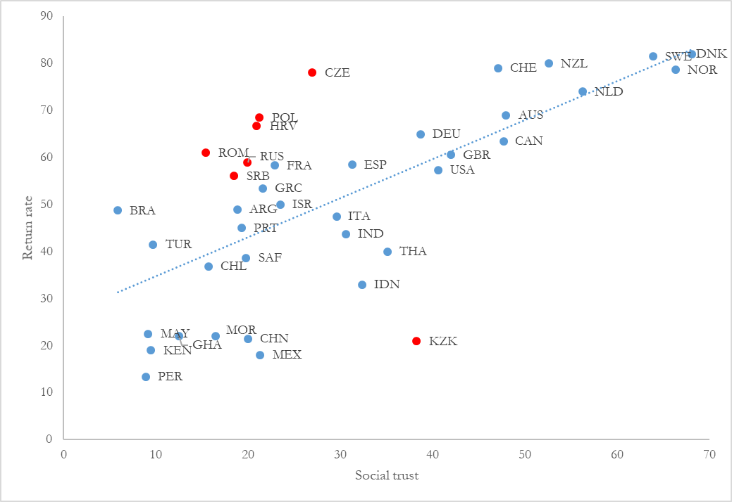

Uslaner (2002, 2016) offers more detailed information concerning what the scores measure at the level of individuals. The 2000 ANES pilot survey asked a series of questions where almost 75% of those who responded said that the trust question measured their moral attitude towards the world rather than their encounters with others. This type of trust does not appear to reflect any kind of reputation or Bayesian updating effect (Uslaner 2002, 141). The standard trust question then is “tied to people you do not know” such as those who work at your grocery store or doctor’s office. Naef and Schupp (2009) find similar results in a large German survey that includes the standard trust question but adds three further questions about strangers. They find that questions about the behavior of strangers is highly correlated with the standard trust question, but not to trust in people respondents know. So the standard trust question appears to account for the trust people have in strangers. Consequently, there is only modest support in the individual-level data for the claim made by Rothstein (2003) and Beugelsdijk (2006) that the trust question measures the quality of formal institutions, such that people generalize from observing the behaviour of civil servants.
There is further evidence favouring using the standard trust question, this time from trust games in the laboratory (Glaeser et al. 2000). The authors play a new version of the Berg et al. (1995) trust or “investment” game with students. In the original game, a sender receives some amount of funds (x) and can decide to offer a share s of her pot x to the receiver, who then acquires a multiple t of sx (often the amount sent is tripled, i.e. t = 3). In the next stage the receiver decides whether to return an amount y to the sender. The payoffs will thus be
(1 – s)x + y for the sender and sxt – y for the receiver. The Nash equilibrium in the game is to return nothing and send nothing. Nonetheless, most people send a lot of their original pot and receive a large amount in return. These exchanges are a way to measure how much senders trust receivers, and how much they trust most people when experimenters anonymize receivers appropriately while return behaviour represents trustworthiness and reciprocity. Importantly, when players are not anonymous, trust behaviour and the standard trust question are more weakly correlated, but since anonymized sharing is arguably a better proxy for generalized trust, the anonymized experiments are more suited for verifying the validity of the standard trust question. There is further work demonstrating that actual trusting behavior is measured by the trust behavior as well (Fehr et al. 2003; Capra, Lanier, and Meer 2008). Cox et al. (2009) play both the ultimatum games and public goods games; they find that people who have not studied economics or strategic thinking act as the standard trust question predicts, and subject behavior is strongly correlated across the different games.
Sapienza, Toldra, and Zingales (2013) find similar results, namely a correlation between the WVS trust question and trust behavior, though only when the stakes of these games are sufficiently high. They say that “WVS-like questions are good at capturing the expectation component of trust” but subject preferences for fairness and equality provide a better account of their behavior with low stakes (Sapienza et al. 2013). People will act expressively when the costs of expressive behavior are low, but as costs increase, rational behavior begins to dominate expressive behavior (Hillman 2010). More recently, experimental approaches have confirmed the link between answers to the trust question and behaviour. For example, Thöni et al. (2012) show, using a public good experiment, that answers are related to cooperation behavior and can be interpreted as a proxy for cooperation preferences. In sum, evidence supports the hypothesis that the GSS/WVS standard trust question actually captures a simple, yet socially relevant conception of trust.
Things are more complicated when social trust is measured cross-nationally, as they exhibit a lot of noise, and may pick up other attitudes (Capra et al. 2008). The fourth waves of the World Values Survey reveal some oddities, such as that Canadian trust seems to have fallen from 54% to 39% by the fourth wave in 2000, but three other surveys taken at the same time (Canadian National Election Study, Quebec Referendum Study, and University of British Columbia Social Capital Survey) all find a 54% trust level – perfectly stable across three different measures. A similar problem applies to British surveys, where a much-discussed drop in the 1990 and 1999 World Values Survey is nowhere to be seen in the contemporaneous British Social Attitudes Survey. Iran also appears to have a 60%+ Nordic level of trust in 1999 and a 10% trust level in 2005. China has WVS scores that are off of predicted values by two whole standard deviations. Belarus and Vietnam yield similar anomalies. Nonetheless, there is a strong correlation between different barometers in different regions of the world, namely Latin America, Africa, the Arab world, Asia and East Asia, and Europe: .85. The correlation between the Danish Social Capital Project and the WVS is .94.
Further, the cross-country and cross-state fluctuations in social trust levels can be predicted precisely by a small number of background variables (cf. Brown and Uslaner 2005; Delhey and Newton 2005; Berggren and Jordahl 2006; Bjørnskov 2007). This observation helps to back up the accuracy of the simple trust measures across countries and across time between those countries.
Critically for our purposes, trust in institutions is measured very similarly, and so the challenges and defensive strategies used to back up the social trust data back up the use of the legal and political trust data as well. Indeed, trust in other institutions is measured somewhat differently in terms of a four-point scale, but the trust questions are very similar. Surveyors don’t try to elicit anything but simply ask basic trust questions targeted at particular institutions. However, a number of other factors play into institutional trust questions since people may have idiosyncratic knowledge of the behavior and the expectations of those institutions.
It is also important to understand that people really do have tailored trust opinions about different institutions. Trust in political parties can be far lower, for instance, than trust in the police or the military (in fact, this is extremely common). For our purposes, we are looking at the relationship between social trust and trust in what Rothstein and Stolle (2003) call order institutions, which as noted, we will call legal trust. So we do not need to provide a defence of the validity of trust scores for trust in democratic institutions or the civil service, just police and courts. There are some important differences between trust in the police and trust in the courts as well; people generally interact with the police far more, and police control more of their lives, but courts have greater power overall (Bradford, Jackson, and Hough 2018). Citizens must rely on the police more, and police much rely on citizens. People also arguably draw inferences about the trustworthiness of an institution based on taking an encounter with a police officer or judge as representative of that group as a whole (unlike trusting most people; trust in known others comes apart from trust in strangers).
Bradford, Jackson, and Hough, in a literature review on legal trust (more specifically the police and criminal courts), offer several claims about the nature and sources of legal trust, five of which are relevant for our purposes (12): (1) Trust in legal authority is primarily cognitive, that is, based on beliefs, (2) Trust is tied to beliefs about the ability and intentions of legal officials, (3) Trust is based on direct and indirect experience with legal officials and their abilities and intentions, though (4) Trust is still based on generalized motivations to trust; people often want to trust the legal system, (5) Trust is partially generated by how legal officials act to reveal that they share values with trustors.
Brown and Benedict (2002) conclude that only three individual-level variables correlate with attitudes towards police – age, ethnicity, and contact with officers – though the levels vary across studies. Older people trust police more than younger people, people from the dominant ethnic group trust police more than ethnic minorities, and people who have recently interacted with police tend to have lower trust in them (Bradford, Jackson, and Hough 2018). There is also some research on trust in courts based on US data, typically stressing procedural justice concerns as the strongest predictor of trust and confidence in the courts, also among offenders when controlling for their overall satisfaction of the outcome of their case (Tyler 2001; Sprott and Greene 2010) though trust in courts is measured in the same way as trust in police.

- Historical Background: The Legacy of British and French Colonialism

Several authors have analyzed differences between British and French colonial strategies (Cohen 1970; Lee & Schultz 2012; Njoh 2008; Whittlesey 1937). An early account appeared in Foreign Affairs when Whittlesey (1937) described the British tendency towards governing Africans through their native rulers, the model of so-called indirect rule. The French, in contrast, typically put their own countrymen on important positions in the colony’s administration.
The difference is described in more detail by Cohen (1970), who noted the French desire to “eradicate the political and social peculiarities of the colonial populations and pattern them after those existing in France” (p. 430). Cohen emphasized that in the French colonies, indigenous societies and traditional leaders were distrusted, and the goal was to make colonies an integral part of France. In contrast, the British saw the end product of their colonial rule to be independence: “Instead of transforming the colonial societies into extensions of Britain the colonies were encouraged to develop along their own lines, thus preserving the best within traditional African and Asian society” (p. 430).
Another difference that plausibly have had impact on institutional trust is the practice in French colonies to rely on forced labor, in the form of annual so-called ‘prestations’ (Cordell and Gregory 1982). In practice, the prestations meant that colonial officials were able to divert laborers for work on private farms and plantations.
In all, it seems clear that the British typically left more traditional structures and institutions intact. There is also some evidence that the difference had both economic and social consequences. Lee and Schultz (2012) make use of the fact that a part of Cameroon was once colonized by Britain, with the border cutting across ethnic and religious boundaries. They show that show that rural areas on the British side have higher levels of wealth and better local public provision of piped water. To explain these results, they point to the British strategy of indirect rule described above and to the presence of forced labor on the French side, that arguably made it harder to generate institutional trust and overcome free rider problems when building small scale public works.
Another way in which French colonial rule may have had an impact on institutional trust is in colonial infra-structure. As discussed by Starostina (2010) the railroads that were built in French colonies (using forced labor) were often not completed. They were built primarily as a way to boost the spirit of the French nation.
In sum, the French staffed legal institutions with their own people, who were not seen as representatives of African societies controlled by the French, whereas the English staffed legal institutions with locals. These patterns seem to have continued somewhat even in the absence of French and English state control.

- Data

We provide estimates of the association between social trust and legal trust at both the individual and country level in order to avoid committing an ecological fallacy (cf. Bjørnskov and Sønderskov, 2013). In both cases, we use the AfroBarometer survey and dataset. As already mentioned, the AfroBarometer is a pan-African research network that conducts attitude surveys in African countries, and is similar to the World Values Surveys or the European Social Survey. The AfroBarometer is increasingly being used in research related to Africa (e.g. Eifert et al. 2010; Nunn 2010). For each of the six currently available rounds of the survey, there are rarely fewer than 1100 respondents per country and large countries such as Egypt and Nigeria typically include more than 2000 respondents.
With a sample designed to be a representative cross-section of all citizens of voting age in a given country, the survey questions are focused on attitudes toward democracy but also cover socio-demographic information of the respondents. In rounds 1, 3, and 5, the questionnaire included the standard dichotomous question of social trust: “In general, do you think most people can be trusted or do you have to be very careful?”
In the individual-level analysis, we use round 5, which includes 34 countries. It offers us assessments of how much respondents trust five separate formal institutions. All respondents were asked “How much do you trust each of the following, or haven’t you heard enough about them to say?” and given the answer categories “Not at all, just a little, somewhat, a lot and I don’t know.” We use the answers to the following formal institutions: Courts of law, the police, the national electoral commission, the parliament, and the ruling party.
We add a set of control variables, all of which also derive from the AfroBarometer survey. We include a dummy for women, the respondent’s age, and his or her self-perceived economic situation assessed as Fairly bad, Neither good nor bad, Fairly good, or Very good. We also include whether the respondent is unemployed, has part-time employment or is full-time employed; the comparison group is thus self-employed. We also include dummies for whether the respondent has only primary education, secondary education, or post-secondary education. For all control variables, we include a separate dummy if the respondent has answered “Don’t know”. Finally, we include a full set of fixed effects of self-assessed racial group.
In additional tests, we employ an additional feature of the AfroBarometer that was asked in all but one country (Swaziland) in round 5: Which, if any, political parties the respondent supports. We use this information to code if respondents support the incumbent / ruling party, which provides us with a way to separate potentially informed trust in specific institutions with ideologically motivated – and therefore potentially expressive – declared support for whichever interest is in power.
In the cross-country application, we use the AfroBarometer to form an unbalanced panel of up to 62 observations from 34 countries. We combine the country-wave averages of the institutional variables and social trust available in rounds 1, 3 and 5, with six additional control variables. First, we use the dichotomous democracy indicator from Cheibub et al. (2010), as updated in Bjørnskov and Rode (2020). From the same dataset, we include dummies capturing whether countries have been either British or French colonies prior to independence. Second, we use the measure of (absence of) government repression from Fariss (2014). Additionally, we form a variable that captures the share of the last twenty years in which a country has been at war; our historical information is mainly from Encyclopaedia Britannica (2018). Third, we include real purchasing-power adjusted GDP per capita, which we derive from the Penn World Tables, mark 9 (Feenstra et al. 2015). Finally, we add fixed effects for rounds 1 and 3 in order to take out average changes from the different number of countries in each round. All individual level data are described in Table 1a while all cross-country data are described in Table 1b.

Table 1a. Descriptive statistics, individual-level data
Variable | Mean | Standard deviation | Observations
Trust in courts | 2.144 | 1.837 | 51,122
Trust in the police | 1.719 | 1.519 | 51,122
Trust in parliament | 1.997 | 1.929 | 49,931
Trust in the elect commission | 2.193 | 2.229 | 47,544
Trust in the ruling party | 1.954 | 2.048 | 49.922
Age | 37.182 | 14.606 | 51,157
Gender (female) | .500 | .500 | 51,122
Fairly bad ec. situation | .298 | .457 | 51,122
Neither good nor bad | .206 | .404 | 51,122
Fairly good ec. situation | .259 | .438 | 51,122
Very good ec. situation | .042 | .199 | 51,122
Don’t know situation | .003 | .053 | 51,122
Unemployed | .286 | .452 | 51,122
Part-time employed | .115 | .319 | 51,122
Full-time employed | .216 | .411 | 51,122
Don’t know employment | .004 | .060 | 51,122
Primary education | .319 | .466 | 51,099
Secondary education | .351 | .477 | 51,099
Post-secondary education | .127 | .333 | 51,099
Don’t know | .002 | .044 | 51,099
Social trust | .186 | .389 | 51,122
Don’t know | .012 | .111 | 51,122

Table 1b. Descriptive statistics, individual-level data
Variable | Mean | Standard deviation | Observations
Trust in courts | 2.796 | .342 | 64
Trust in the police | 2.613 | .413 | 64
Trust in parliament | 2.666 | .410 | 51
Trust in the elect commission | 2.691 | .366 | 61
Trust in the ruling party | 2.586 | .414 | 51
Democracy | .392 | .491 | 102
(Absence of) repression | -.140 | .825 | 102
War (share of years) | .186 | .285 | 102
Log GDP per capita | 7.829 | .934 | 102
Former British | .471 | .502 | 102
Former French | .383 | .488 | 102
Social trust | .188 | .102 | 62

  - A first look at the data
When exploring the country averages, there is considerable variation across countries when it comes to institutional trust. For example, the population share with at least some trust in the courts of law is as low as 29 percent in Madagascar (an index of 1.31), but as high as 82 percent (2.35) in Niger, as indicated in Figure 1 below. Trust in other institutions also varies markedly across countries with the additional common feature that institutional trust tends to be substantially higher among respondents who support the incumbent, ruling party.
Similarly, the share of respondents stating that “most people can be trusted” varies from 5 percent in Lesotho to 55 percent in Burundi. Again, we observe that supporters of the ruling party tend to be more trusting than non-supporters. However, the association between social trust and legal trust, despite the similarities, appears to be fragile at best across Africa. As is visible in Figure 2, the cross-country correlation between social trust and trust in courts is positive, but it is entirely driven by the only two countries with high levels of social trust: Burundi (55 percent) and Niger (46 percent).

Figure 2. Social and legal trust in the AfroBarometer
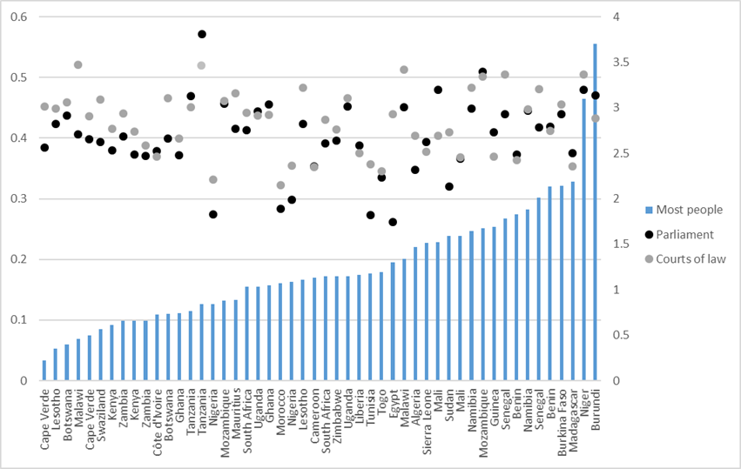

  - Empirical results

Analyzing survey data on individual characteristics uncovers some noteworthy patterns in trust in the five institutions of interest. Women are on average more prone to trusting all institutions, whereas education associates negatively with institutional trust. In other words, the better educated and presumably better informed are less likely to trust formal institutions in Africa. Conversely, there is a strong positive association between household income and trust in formal institutions with one notable exception: Respondents who declare that they “don’t know” their income – or more likely refuse to reveal it – are most trusting towards formal institutions. However, such refusals are often correlated with having particularly high incomes, which may resolve what otherwise appears as a puzzle.

Table 2: Individual-level results
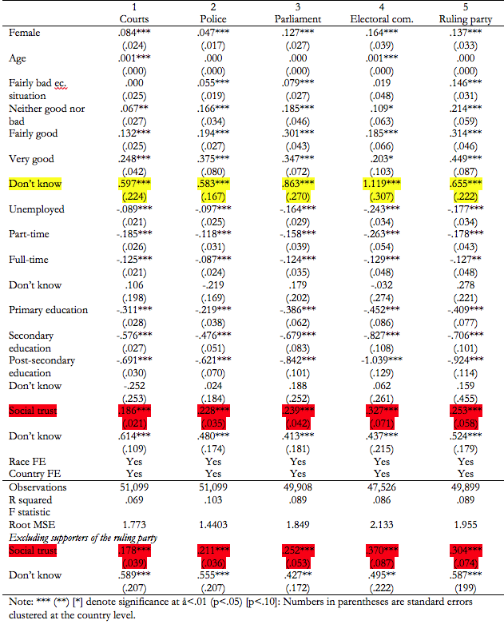

Most importantly, controlling for individual characteristics, and including controls for race and country fixed effects, as reported in Table 2, we find a significant positive association between social trust and (all five types of) legal and political trust (political trust understood as trust in political institutions like parliament and the ruling party).
When we turn to the cross-country regressions in Table 3, we again find that social trust is positively associated with trust in formal institutions, although not significantly associated so for courts and the police. At first glance, the cross-country analysis thus corroborates the individual-level results. The analysis also reveals a highly intuitive positive association between absence of repression and institutional trust, and an interesting difference depending on colonial heritage such that former French colonies tend to have lower institutional trust.

Table 3: Cross-Country Results
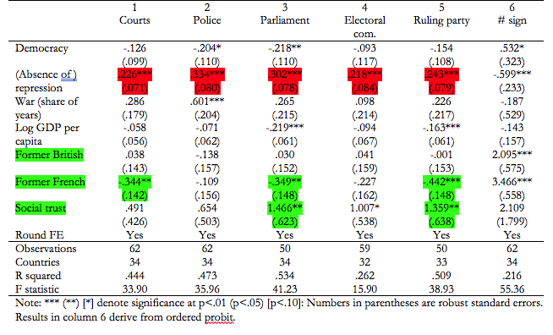

The individual-level results nevertheless turn out to hide some interesting heterogeneity between countries. As we outline in Table 4, which summarizes the main results from a full set of jackknife tests, including tests in which we only include respondents who do not support the ruling party, the main results are not as robust as in other settings. We further use the number of significant associations across the five types of formal institutions as the dependent in column 6 of Table 3.
In some countries, individual trust is positively associated with trust in all five institutions. An example is Niger, and the association between social trust and institutional trust is there also when respondents who do not support the ruling party are excluded from the sample. In contrast, there are several countries where the association between social trust and institutional trust is partly or completely driven by supporters of the ruling party, such as Burundi and Togo. In these cases, we cannot claim a general, robust association exists.
Overall, our findings suggest that the strength of the otherwise well-known association between social trust and trust in formal institutions is not as general in Africa as in the developed world. The summary in Table 4 suggests that the association particularly often breaks down when we focus on respondents’ trust in courts.
As a final test, we separate former French and British colonies. This additional test shows that the five different trust-institutions associations are generally significant in 65% of cases the 13 French colonies while it is only significant in 27% of cases in the latter 15 countries. As we outline in the discussion in the last section, we interpret this as a partial confirmation of our hypothesis that part of the reason that the correlation between social and legal trust comes apart in Africa is because of the legacy of colonialism.

Table 4. Countries driving results
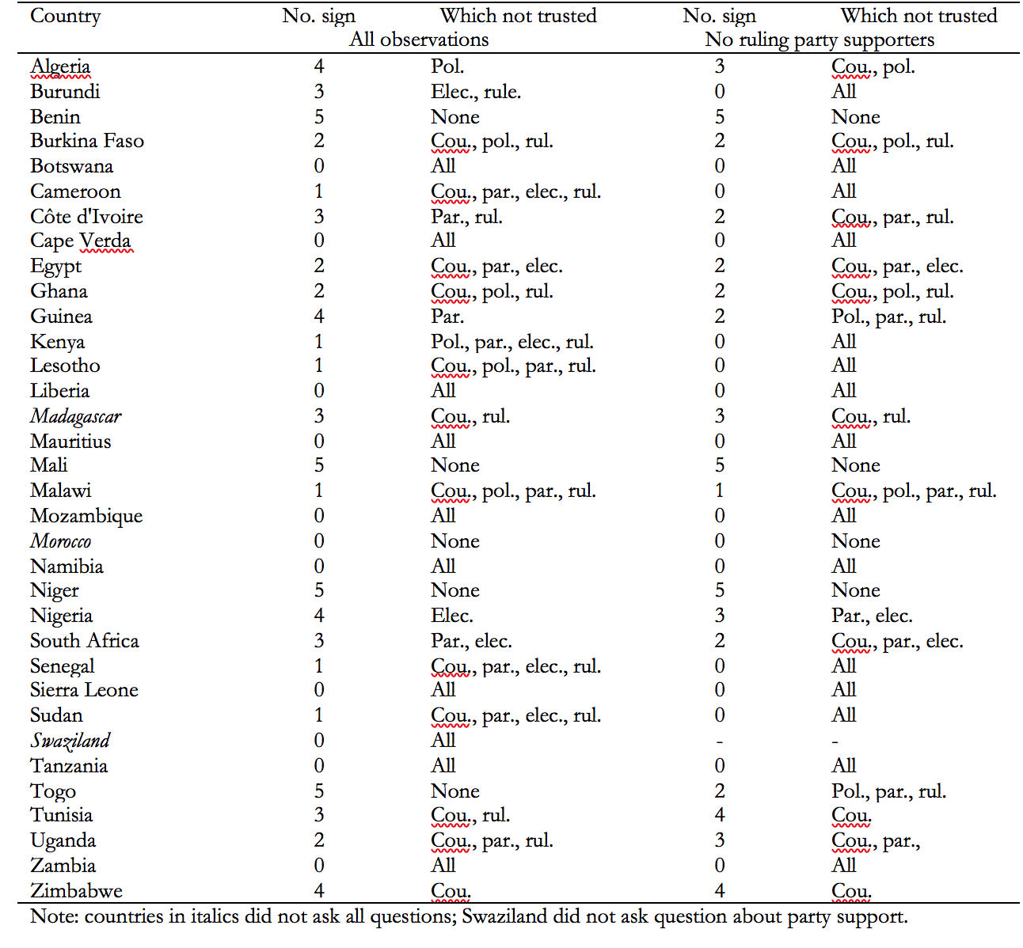

- Discussion
We have here explored the association between social trust and trust in formal institutions: the courts, the police, parliament, the electoral commission, and the ruling party. In general, we find the association is positive at both the cross-country and individual level. However, we find very substantial heterogeneity across African countries such that it is difficult to make general claims.
Overall, the data nevertheless appear to be consistent with our hypothesis about how legal trust judgments change in accord with judgments about the representativeness of legal officials. However, do these results tell us how legal trust is formed and whether it affects social trust? There are three questions we might ask about the significance of our findings.
- Why is legal trust usually higher than social trust when legal officials are seen as representative of society, i.e. when current legal systems are not likely to be the remnants of the former colonial institutions?
- Why is legal trust more proportionate to social trust when legal officials are seen as representative of society?
- What are the causal relationships between social and legal trust that are consistent with the answers to 1 and 2?
Regarding question 1, let’s first note that legal trust is almost always higher than social trust even when legal and social trust are weakly correlated, as we have seen above. This may be because police and courts, among other legal institutions, are seen as more trustworthy in general because of the importance and visibility of their occupations, the fact that they are seen as neutral and treating citizens similarly, especially in contrast to political officials, and that they may be subject to effective checks and balances on the behaviour of judges and bureaucrats.
We wonder whether this effect is sensitive to whether police and judges are in fact more trustworthy, such that legal trust is at least partially a response to the observation or seeming observation of trustworthy behaviour. One possibility is that legal officials tend to act in a trustworthy fashion on balance, and they do so in very visible and important ways, such as keeping people safe or helping them redress wrongs at critical points in their lives. This suggests that legal trust is higher when individuals have positive experiences with legal officials. However, in further tests, we find that quasi-objective indicators of quality, such as the rule of law indicator from the World Governance Indicators (Kaufmann et al. 1999), don’t correlate with social trust in our African sample. So this possibility seems less likely.
Regarding question 2, when legal officials are seen as representative of their society, people may form legal trust judgments by first consulting their social trust judgments and then combine it with their belief in the greater relative trustworthiness of legal officials to generate a legal trust judgment. Thus, when legal officials are seen as representative, people believe that social trust judgments are helpful for determining the trustworthiness of legal officials. But when legal officials are not seen as representative, people will rely more on other judgments about legal officials. Our main argument here is that legal officials in former French colonies are much more likely to be representative, as France transplanted its own institutions with French civil servants in its colonies, and most civil servants and legal officials consequently also left when these colonies gained their independence. Conversely, former British colonies are substantially more likely to have legal institutions – most visibly in Botswana – that are the direct descendants of the colonial institutions and thus unlikely to be representative (Acemoglu et al. 2003).
Perhaps, then, legal trust in non-representative officials is largely a function of beliefs about legal trustworthiness unmediated by a social trust judgment, such that legal trust is determined by reputation effects and personal experience, and perhaps a general desirability belief that the police and courts can keep one safe. However, if legal officials are representative, then social trust judgments mediate legal trust judgments, allowing people to develop more precise legal trust judgments based on more information, and this tends to yield higher legal trust judgments.
Regarding question 3, it appears that individuals formulate legal trust judgments by drawing on a number of antecedent beliefs, and that if a person believes that legal officials are representative of society, this goes into the mix of beliefs that determine legal trust. So social trust leads to legal trust by providing proxy information for legal trust judgments.
There are some claims in the empirical literature that legal trust and trustworthiness impact social trust. One reason for this is that good police and courts enforce formal and informal social norms, which gives people additional motivation to be trustworthy, which will generate social trust judgments in turn. Thus, on the one hand, legal trust should cause at least some portion of social trust because it increases the observational basis for trust. This might help explain why legal trust judgments are higher than social trust judgments, because legal officials are seen as keeping most people honest and well-behaved. On the other hand, such mechanisms only make logical sense if social trust is effectively an individual risk assessment. If trust is instead driven by emotions that are independent of the consequences of trusting (as argued in e.g. Schlösser et al. 2016 and Dunning et al. 2012), institutions might not matter at all, and trust would be explained by cultural factors such as upbringing.
Legal trust may be higher in countries where social and legal trust are correlated than in countries where they are not correlated. This would be the case, for example, if legal institutions are populated in a fair and meritocratic way, such that legal officials will be representative of “most people.” However, such an explanation is inconsistent with our finding that trust in institutions is generally lower in former French colonies and that the association between social and institutional trust is weaker in these countries. We also note that if only a relatively small minority of people can be trusted, as appears to be the case in a number of African countries, most ordinary citizens would be interested in legal institutions with officials that are emphatically not representative of most people.
A main observation is that legal officials can still enforce formal and informal norms when they are not representative. It may indeed well be that unrepresentative legal officials may still be effective, such that they are seen as trustworthy and keeping others trustworthy. Strictly speaking, then, our findings are compatible with the claim that legal trust and trustworthiness causes social trust in some cases. But if the relevance of representativeness judgments works as we hypothesize, then it seems to provide a bit more support for the hypothesis that legal trust is a function of social trust and not as much the other way around because it reveals that social trust judgments are consulted in making legal trust judgments.

References
Acemoglu, Daron, Simon Johnson and James Robinson. 2003. An African Success Story: Botswana. In Dani Rodrik (Ed.), In Search of Prosperity: Analytic Narratives on Economic Growth. Princeton, Princeton University Press, 80-122.
Berg, Joyce, John Dickhaut, and Kevin McCabe. (1995). Trust, Reciprocity and Social History. Games and Economic Behavior 10, 122-142.
Berggren, Niclas, and Henrik Jordahl. (2006). Free to Trust? Economic Freedom and Social Capital. Kyklos 59, 141–169.
Beugelsdijk, Sjoerd. (2006). A Note on the Theory and Measurement of Trust in Explaining Differences in Economic Growth. Cambridge Journal of Economics 30, 371–387.
Bjørnskov, Christian. (2007). Determinants of Generalized Trust. A Cross-Country Comparison. Public Choice 130, 1–21.
Bjørnskov, Christian. (2010). How does Social Trust lead to Better Governance? An Attempt to Separate Electoral and Bureaucratic Mechanisms. Public Choice 144, 323-346.
Bjørnskov, Christian. (2019). Civic honesty and cultures of trust. Working paper, Aarhus University.
Bjørnskov, Christian, and Martin Rode. (2020). Regimes and regime transitions: a new dataset on democracy, coups, and political institutions. Review of International Organizations 15, 531-551. Data available at http://www.christianbjoernskov.com/bjoernskovrodedata/ (accessed September 2018).
Bjørnskov, Christian and Kim Mannemar Sønderskov. 2013. Is social capital a good concept? Social Indicators Research 114, 1225-1242.
Bradford, Ben, Jonathan Jackson, and Mike Hough. 2018. Trust in justice. In Eric M. Uslaner (ed.), Oxford Handbook of Social and Political Trust. Oxford, Oxford University Press, 633-653.
Bratton, Michael and E. Gyimah-Boadi. 2016. Do trustworthy institutions matter for development? Corruption, trust, and government performance in Africa. Afrobarometer Dispatch No. 112.
Brown, Ben and William Reed Benedict. (2002). Perceptions of the police: Past findings, methodological issues, conceptual issues and policy implications. Policing 25, 543-580.
Brown, Mitchell, and Eric M. Uslaner. (2005). Inequality, Trust, and Civic Engagement. American Political Research 31, 1–27.
Capra, C. Mónica, Kelli Lanier, and Shireen Meer. (2008). Attitudinal and Behavioral Measures of Trust: A New Comparison. Working Paper, Emory University.
Cheibub, José A., Jennifer Gandhi, and James R. Vreeland. 2010. Democracy and dictatorship revisited. Public Choice 143, 67-101.
Cohen, W. B. (1970). The Colonized as Child: British and French Colonial Rule. African Historical Studies, 3(2), 427–431.
Cohn, Alain, Michel André Maréchal,, David Tannenbaum, and Christian Lukas Zünd. 2019. Civic honesty around the globe. Science 365, 70-73.
Cordell, D. D., and Gregory, J. W. (1982). Labour Reservoirs and Population: French Colonial Strategies in Koudougou, Upper Volta, 1914 To 1939. Journal of African History 23(2), 205–224.
Cox, James C., Elinor Ostrom, James M. Walker, Antonio Jaime Castillo, Eric Coleman, Robert Holahan, Michael Schoon, and Brian Steed. (2009). Trust in Private and Common Property Experiments. Southern Economic Journal 75, 957–975.
Delhey, Jan, and Kenneth Newton. (2005). Predicting Cross-National Levels of Social Trust: Global Pattern or Nordic Exceptionalism? European Sociological Review 21, 311-327.
Encyclopædia Britannica, 2018. Censorship. Online encyclopedia, accessed at https://www.britannica.com/topic/censorship#ref358885 (July, 2018).
Eifert, Benn, Edward Miguel, and Daniel N. Posner. 2010. Political competition and ethnic identification in Africa. American Journal of Political Science, 54, 494–510.
Fariss, Christopher J. 2014. Respect for human rights has improved over time: modeling the changing standard of accountability. American Political Science Review 108, 297-318.
Feenstra, Robert C., Inklaar, Robert, & Timmer, Marcel P. (2015). The next generation of the Penn World Table. American Economic Review 105, 3150–3182.
Fehr, Ernst, Urs Fischbacher, Bernhard von Rosenbladt, Jürgen Schupp, and Gert Wagner. (2003). A Nation-Wide Laboratory. Examining Trust and Trustworthiness by Integrating Behavioral Experiments into Representative Surveys. CESIfo working paper 866.
Felton, Eric. (2001). Finders Keepers? Reader’s Digest, April, 103-107.
Fine, Ben. (2001). Social Capital versus Social Theory. Routledge: London.
Glaeser, Edward, David Laibson, J, Scheinkman, and C. Soutter. (2000). Measuring trust. Quarterly Journal of Economics 115, 811–846.
Hillman, Arye. (2010). Expressive behavior in economics and politics. European Journal of Political Economy 26, 404 – 419.
Holm, Hakan, and Anders Danielson. (2007). Tropic Trust versus Nordic Trust: Experimental Evidence from Tanzania and Sweden. The Economic Journal 115, 505-532.
Kaufmann, Daniel, Aart Kraay and Pablo Zoido-Lobatón. 1999. Aggregating Governance Indicators. World Bank Policy Research Working Paper #2195.
Knack, Stephen. 2001. Trust, Associational Life and Economic Performance. Pp. 171-202 in The Contribution of Human and Social Capital to Sustained Economic Growth and Well-Being, edited by John F. Helliwell. Quebec: Human Resources Development, Canada.
Knack, Stephen, and Philip Keefer. (1997). Does Social Capital Have an Economic Pay-Off? A Cross-Country Investigation. Quarterly Journal of Economics 112, 1251–1288.
Lee, A., & Schultz, K. A. (2012). Comparing British and French Colonial Legacies: A Discontinuity Analysis of Cameroon. Quarterly Journal of Political Science 7(4), 365–410.
Naef, Michael, and Jürgen Schupp. (2009). Measuring Trust: Experiments and Surveys in Contrast and Combination. SOEP working paper 167, DIW Berlin.
Njoh, A. J. (2008). Colonial Philosophies, Urban Space, and Racial Segregation in British and French Colonial Africa. Journal of Black Studies 38(4), 579–599.
Nunn, Nathan. 2010. Religious conversion in Colonial Africa. American Economic Review Papers and Proceedings, 100, 147–152.
Rosenberg, M. (1956). Misanthropy and political ideology. American Sociological Review 21, 690–695.
Rothstein, Bo. (2003). Social Capital, Economic Growth and Quality of Government. New Political Economy 4, 9-72.
Rothstein, Bo and Dietlind Stolle. (2003). Introduction: social capital in Scandinavia. Scandinavian Political Studies 26, 1‒26.
Rothstein and Stolle. (2008). Political institutions and generalized trust. In Dario Castiglione, Jan W. van Deth and Guglielmo Wolleb (Eds.), The Handbook of Social Capital. Oxford, Oxford University Press.
Sapienza Paola, Anna Toldra-Simats, and Luigi Zingales. (2013). Understanding trust. The Economic Journal 123, 1313–1332.
Sprott, Jane B., and Carolyn Greene. 2010. “Trust and Confidence in the Courts.” Crime & Delinquency 56(2): 269–89.
Thöni, Christian, Jean Robert Tyran, and Erik Wengström. 2012. Microfoundations of Social Capital. Journal of Public Economics 96(7–8): 635–643.
Tyler, T. R. (2001). Public trust and confidence in legal authorities: What do majority and minority group members want from the law and legal institutions? Behavioral Sciences & the Law, 19, 215-235.
Uslaner, Eric M. (2002). The Moral Foundations of Trust. Cambridge: Cambridge University Press.
Uslaner, Eric M. (2016). Measuring Generalized Trust: In Defense of the ‘Standard’ Question. In Handbook of Research Methods on Trust, edited by Fergus Lyon, Guido Möllering, Mark Sanders, and Tally Hatzakis, 97-106. London: Edward Elgar.
Yamagishi, Toshio, and Midori Yamagishi. (1994). Trust and Commitment in the United States and Japan. Motivation and Emotion 18, 129-166.Whittlesey, D. (1937). British and French Colonial Technique in West Africa. Foreign Affairs 15(2), 362.

Our jackknife consists of running all analyses excluding one country at a time. We repeat all analyses excluding respondents who support the ruling party in order to avoid that our individual-level results are due to reflection. This could be the case if respondents who support the ruling party generally declare themselves to be more positive towards all aspects of society.

